**Image segmentation by machine learning**

**using multi-sensor imageries**

*A report submitted to*

**Techno India University, West Bengal**

*for the partial fulfilment of*

**Bachelor of Technology (B. Tech.)**

*degree in*

**Computer Science & Engineering**

By

Hriyam Dutta 191001001092

Jasmit Kaur 191001001080

Debargha Pakhira 191001001093

Arghya Gupta 191001001224

Kesang Yanki Bhutia 191001001009



DEPARTMENT OF COMPUTER SCIENCE & ENGINEERING

TECHNO INDIA UNIVERSITY, WEST BENGAL,

SALT LAKE, KOLKATA – 700091, INDIA

Jan 2023

© 2023, Techno India University. All rights reserved.

CONTENTS

## TITLE PAGE N0.

### Abstract ………………………………………………………………... 4

### Introduction ……………………………………………………………. 5

### Problem Statement …………………………………………………… 6

### Approach ………………………………………………………………. 7

### Methodology …………………………………………………………… 8

### Scientific Material and tools …………………………………………. 12

### Literature Review …………………………………………………….. 13

### Conclusion …………………………………………………………….. 30

### References …………………………………………………………….. 32

### 

ABSTRACT

Image segmentation is a critical step in many image processing and computer vision tasks, such as object detection, image compression, and image editing. The goal of image segmentation is to partition an image into multiple regions, or segments, such that each segment corresponds to a specific object or feature in the image.

By segmenting images, it becomes possible to analyse each segment separately (and extract information such as the shape, size, texture, and colour of the objects) and also to apply image processing algorithms on each of them.

Image fusion is the process of combining multiple images of the same scene to create a new image with enhanced information.The fused image should have higher spatial and spectral resolution, higher contrast, and fewer noise and distortions than the individual images.

Different types of Images can be fused here we tend to fuse Panchromatic Images(for higher resolution and contrast) and Multispectral Images(for efficient spectrum of light)

Inorder to do so, we initially register the images to eliminate the

Indifferences in their resolution and spatial alignment.

Finally, we look forward to achieving efficient segmentation using fused image plates to further help us for object detection as our future project scope.

**Keywords** **:** Image Registration, Panchromatic Image, Multispectral Image, Image Fusion, Affine Transformation, Image Segmentation.

INTRODUCTION

Image segmentation is the process of dividing the image into multiple segments or regions. It is an essential task in computer vision and remote sensing image analysis, as it allows extracting specific information from an image, such as object recognition and tracking.

The use of machine learning in image segmentation is becoming highly favoured, as it allows for the automation of the process and the ability to handle large amounts of data. In this project, we propose using machine learning techniques for image segmentation by utilising multi-sensor imagery and combining information from multiple sensors. We will use Multispectral images and Panchromatic images. Multispectral images are rich in material, and Panchromatic images have better resolution than others. Combining the two and using valuable factors from both multispectral and panchromatic images, we aim to improve the accuracy and robustness of the segmentation results.

Our project aims to develop a machine learning-based approach to image segmentation using multi-sensor imagery. By utilising a dataset that contains Multispectral and Panchromatic pair images, we plan to train a model that can accurately segment an image into different regions. The model will be evaluated on its performance using standard metrics such as accuracy, precision, and recall. We will also provide qualitative results to demonstrate the effectiveness of the proposed approach.

Overall, this project will explore the potential benefits of using multi-sensor imagery for image segmentation using machine learning and demonstrate its usefulness in real-world applications.

Future Scope, after completing the segmentation process, we aim for object detection in our segmented regions.

Problem Statement

The main objective of this project is to achieve image segmentation of multi sensor data with the help of machine learning. In this pursuit we have to tackle the following four challenges

1. The data used here are from multi – sensor images i.e. the **resolution of images** from different sensors differ from one another as a result there arises a **geometrical correction** problem within the data. To minimise the error the data used should have the same resolution. To achieve that we need to find an efficient way to **Register** all the images with one another precisely to get accurate data having the same resolution for further development of the project.
2. The data achieved after registration of the multi-sensor of data is accurate.

However, different sensors have **different signatures** and set of advantages and disadvantages.Therefore, we would have to determine **optimal fusion techniques** to fuse these images and produce **high resolution detailed images** which takes the advantage of the information available in each sensor for further analysis and processing of data.

1. The most important and critical problem of our project is **segmentation of the fused images/plates**. We have to determine efficient segmentation techniques within the domain of machine learning so that we can achieve desired level of results from our data
2. We can further explore the potential of this project by aiming for **object/target detection** on a particular region with the help of **machine learning or deep learning** on the **segmented images** achieved in our project.

Approach

Our approach to solve the mentioned problems in our report are explained briefly with help of following steps :

* Image Registration –
* Data Collection and Preprocessing (if required)
* We will perform Intensity and Landmark based registration on Multispectral and Panchromatic Images
* A combination of Polynomial Affine Transformation and GF2 algorithm will be used to register the images
* Image Fusion –
* Once the Images are registered the respective set of Panchromatic and Multispectral Images are then fused
* A list of three algorithms will be experimented upon to find the one that provides the most enhancement of the features we look to work with
* The algorithms are –

Restoration based ;Spatial Consistency based and

Wavelet Transform based

* Image Segmentation –
* The Fused Image plates which are much enhanced with the best of properties from each type of Images will then be further segmented
* The segmentation will be based mostly on –

Region; Edge detection; Pixel-Intensity

* We will eventually run the models on CNN and FCN (along with semantic labelling, wavelet and evidence theory)
* Once the images are segmented we will do error evaluation and enhance our parameters and approach accordingly to arise with as much better possible results.

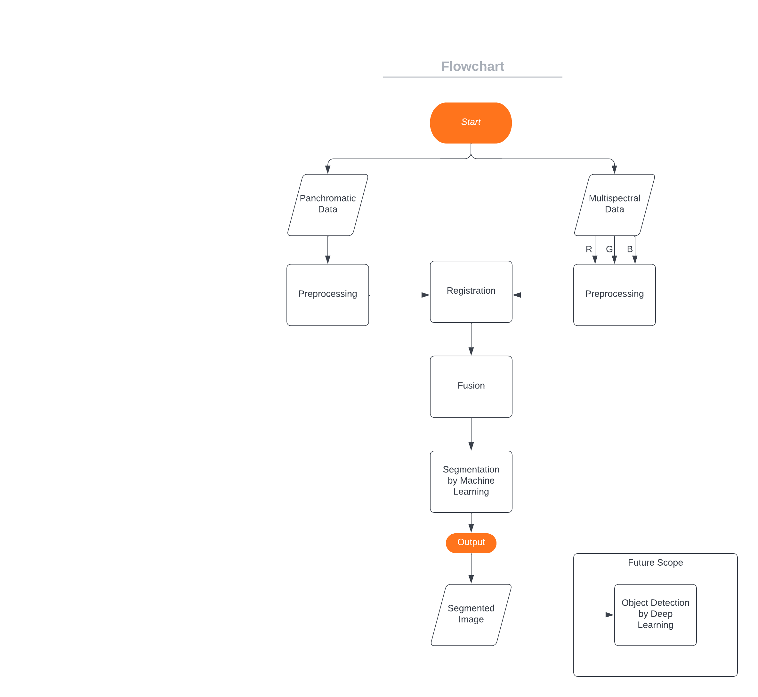METHODOLOGY

Image segmentation is a useful technique for analysing satellite imagery for

for a variety of reasons. Some specific examples of the uses of image segmentation in satellite imagery include; Land use and land cover mapping, Monitoring natural resources , Disaster response and recovery , Infrastructure monitoring , Military and security and many more. Image segmentation is a powerful technique for extracting information from satellite images and can be applied to a wide variety of applications, depending on the specific needs of the task.To get the best form of the segmented image , we use data from different sensors.

In this project we are using multi-spectral and panchromatic images, that

can provide several advantages over using data from a single sensor, like

Increased spectral information, the multi-spectral images provide information in multiple wavelength bands, whereas panchromatic images provide high spatial resolution information. It also provides improved object discrimination , as multi-spectral images are sensitive to different types of materials, and each band can provide information that is not available from other bands, such as the presence of vegetation, water bodies, and urban areas. Panchromatic images, on the other hand, provide high spatial resolution information that can be used to identify objects with fine details. By combining these two types of images, we can get both high spatial and spectral resolution, allowing us to better detect and classify objects and features in the image, we can get a more complete understanding of the objects and features present in the image.

Before doing any further analysis we need to Pre- Process our data , in this case of remote sensing images, the Pre- processing will include Affine Transformation , the correction of geometric distortions caused by the imaging sensor or the terrain, before aligning the images. This step is usually referred to as image rectification.

In the case of multispectral and panchromatic images, registration is necessary to ensure that the images are accurately aligned before they can be fused or used together for further analysis.Registration is the process of aligning two or more images, so that they have the same spatial coordinates. There are several techniques that can be used for registering multispectral and panchromatic images, and the specific technique used will depend on the quality of the images and the specific requirements of the task. To achieve the proper registration for our further analysis , we will be using two registration techniques i.e., Feature-based registration and Automatic registration. In feature-based technique we will be identifying and matching features, such as edges, corners, or blobs, in the two images. Once the features are matched, the position of one image can be adjusted to align the features. This technique can be more robust to noise and poor image quality, but it can be computationally intensive and may not work well for images with limited or low quality features.In Automatic registration , we will be using deep-learning based methods to perform registration automatically.This can include using a CNN to predict the displacement between two images, or using a variant of U-Net architectures to estimate the transformation between two images.

Once the multispectral and panchromatic images have been registered, they can be fused together to create a single image that combines the high spatial resolution of the panchromatic image with the high spectral resolution of the multispectral image. We will be using Pixel-level Fusion technique. In this the high spatial resolution information from a panchromatic image is used to sharpen the low spatial resolution information from a multispectral image. This is achieved by selecting specific pixels from the panchromatic image and combining them with the corresponding pixels from the multispectral image to create a fused image with both high spatial and spectral resolution.

For our final step we will be segmenting our high spatial and spectral resolution image , to achieve this we will be using three techniques i.e., Region-based segmentation , Edge- based segmentation and Convolutional neural networks (CNNs).Region-based technique involves grouping pixels together into regions based on some criterion, such as proximity or colour similarity. For this method we may use k-means clustering or mean-shift clustering.the edge-based technique involves detection of edges or boundaries in an image. The idea behind edge-based segmentation is that the edges of an object in an image often correspond to significant changes in image intensity, and therefore provide a useful cue for segmenting the object. To increase the accuracy of our segmentation , Finally we can use CNNs , the deep learning method as CNNs have shown to perform better on image segmentation tasks then traditional methods. This is due to the fact that CNNs can learn features from images and generalise better.

Future scope , after successfully completing the image segmentation process , we may proceed with the task of object detection. Object detection is the task of identifying and locating objects within an image. Once an image has been segmented, the process of object detection becomes simpler, as the objects of interest have already been separated from the background.

**# Please note that during the lifetime of our research we might be obliged to use algorithms and techniques apart from the mentioned above to achieve better results keeping the intent for the aim of our project unaltered.**

**## Also we hope to further indulge in increasing the scope of our project Also we hope to further indulge in increasing the scope of our project to explore further horizons of computer vision.**

Scientific Material and Tools

* IRS - 1C : Image Datasets it with Linear Imaging Self-Scanning Sensor-3 (LISS -3) of 23.5 m resolution in NIR 70.5 m. Panchromatic camera with 5.8 m resolution imagery and Wide-Field Sensor of 190 m resolution.
* IKONOS : Image Datasets with spatial resolution of 0.82 - 1 m Panchromatic Imageries and spectral resolution of 3.28 - 4 m Multispectral Imageries . They cover the wavelengths 450 - 900 nm for panchromatic images and 450 - 860 nm for multispectral images opencv library for image processing
* OpenCV Library for Image Processing
* Scikit Learn Library for FCN and other Convolution Neural Networks

Literature Review

**1. Paper Citation: Darshana Mistry, Asim Banarjee (2012) “Review: Image Registration” International Journal of Graphics and Image Processing, Vol 2(1) (February): 18-22.**

This paper presents the survey of Image Registration. It defines Image Registration as — “the process of overlaying images(two or more) of the same scene taken at different times, from different viewpoints, and/or different sensors (references and sense images)[1]. It geometrically aligns two images—the reference and sensed images. The present differences between images are introduced due to different imaging conditions”.

This paper represents different steps of Image Registration -

feature detection, feature matching, transformation method, and resampling and transformation methods.

Thereafter, it discusses the methods of registering images. The paper includes the following methods :

Correlation methods; Wavelet based methods;

Mutual Information; Harris Operator(Corner Detection);

Canny Edge Detection Algorithm.

Affine Transformation: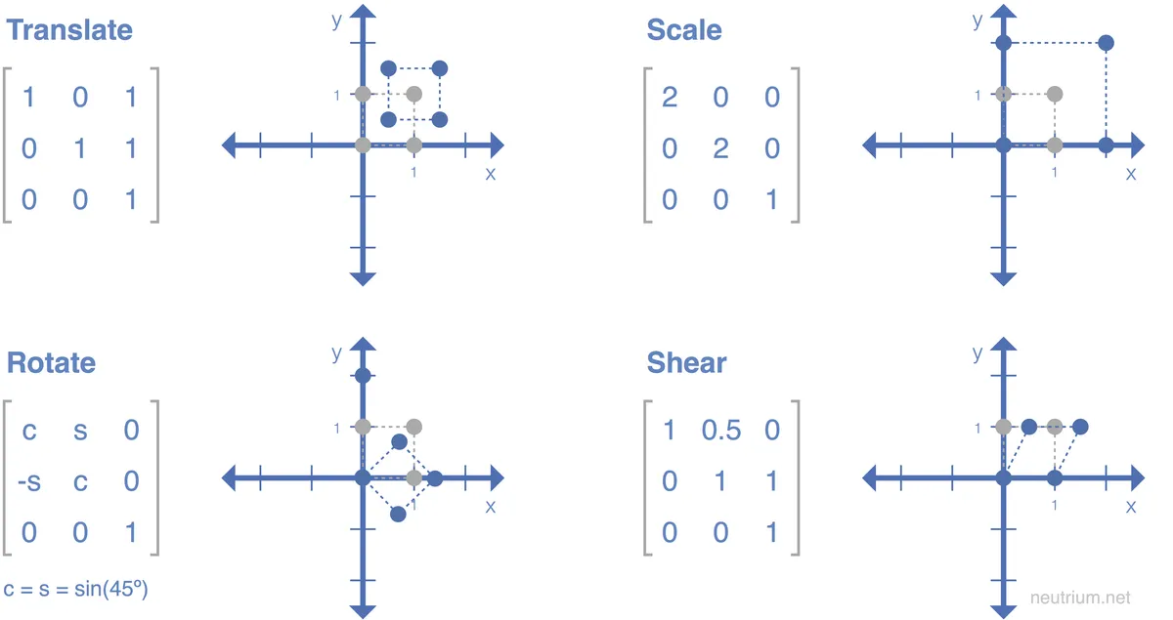

Furthermore, soft computing based methods such as Fuzzy sets, Genetic Algorithm and Artificial Neural Network for the purpose of Image registration are discussed briefly.

This paper shows how image registration is one of the most important and key stage in image fusion, change detection, super-resolution imaging, and in building image information systems.

**2. Paper Citation: Narayan Panigrahi Smita Tripathy(2002) “Image Registration using Polynomial Affine Transformation” Defense Science Journal, Vol 52(3) (July): 253-259.**

In this paper, the authors propose a new method for image registration using polynomial affine transformations. Image registration is the process of aligning two or more images of the same scene taken from different viewpoints or at different times. It is a fundamental step in many image processing and computer vision applications, such as image mosaicing, medical image analysis, and object tracking.

The authors' approach is based on the use of polynomial affine transformations, which are a more general class of transformations than traditional affine transformations;here it is solved by least squared method. These transformations allow for the modelling of nonlinear distortions in the images, which can occur due to variations in viewpoint, lighting, or sensor properties. The authors' method also uses a novel objective function that combines both intensity and gradient information, which they claim results in improved registration accuracy.

One weakness of the paper is that the authors only evaluate their method on a small number of images, and it would be good to see how it performs on a more diverse set of images and in comparison with other recent registration methods. Additionally, more comprehensive evaluation with additional dataset would strengthen the claim of the proposed method.

Overall, the authors make a convincing case for the use of polynomial affine transformations in image registration, and their proposed method appears to be a promising approach. The paper is well-written and easy to follow, and the experimental results are promising. It would be interesting to see the proposed method applied to other image registration problems in the future.

**3. Paper Citation:(2017) Sarit Chicotay , Nathan S. Netanyahu and Eli David “A Two-Phase Genetic Algorithm for Image Registration” (GECCO), Vol 52(3) (July): 189-190.**

The authors propose a two-phase GA approach that includes a coarse-to-fine search strategy, where the first phase uses a global GA to find an approximate registration solution, and the second phase uses a local GA to fine-tune the registration.

The global search phase uses a genetic algorithm to find a rough alignment between the images, while the local search phase refines the alignment using a gradient-based optimization method. This two-phase approach is designed to take advantage of the strengths of both genetic algorithms and gradient-based optimization methods.

The paper is well-written and easy to understand. The authors clearly explain the technical details of the proposed method, and they provide a thorough evaluation of the method using a variety of image datasets. They also provide a comparison of their method with other state-of-the-art registration methods in terms of registration accuracy and computational efficiency. The results show that the proposed two-phase GA method outperforms other methods in terms of registration accuracy.

One strength of the paper is the use of genetic algorithms for image registration. Genetic algorithms are a flexible optimization method that can be applied to a wide range of problems, and they can be used to handle nonlinear and non-convex registration problems. It also gives the added advantage of improved convergence and global optimization capabilities.

However, one weakness of the paper is that they do not provide a detailed explanation of the parameters used in the GA, such as population size, number of generations, and mutation rate. These parameters are crucial in determining the performance of the GA.

**4. Paper Citation:(2020) SEN WANG , XIAOFEI WANG , and JIANXIONG LI “GF-2 Panchromatic and Multispectral Remote Sensing Image Registration Algorithm” (IEEE), Vol8(3) (July): 138067-138076.**

In this paper, the authors propose a new image registration algorithm for panchromatic and multispectral remote sensing images, which they call GF-2. The Approach is based on a feature-based registration algorithm that uses gradient information from both panchromatic and multispectral images. They propose the use of a Gaussian filter to extract the gradient information, which they claim results in improved registration accuracy and robustness. They then use an optimization method to align the images based on the gradient information.

The authors evaluate their method on several sets of real-world panchromatic and multispectral remote sensing images, and show that their method achieves a high degree of registration accuracy and is robust to noise and non-rigid deformations.

One strength of the paper is that the authors evaluate their method on a diverse set of data . They also provide a detailed explanation of the algorithm and its implementation, which allows others to reproduce and evaluate the proposed method.

One weakness of the paper is that the authors do not provide a detailed discussion on the choice of parameters for the algorithm, which could affect its performance especially on different resolution and geometric complexities.

Overall, the authors present a well-designed and well-executed study on image registration for panchromatic and multispectral remote sensing images.

**5. Paper Citation:(2012) Li Ailing and Zhang Boheng “Registration Algorithm of Panchromatic and Multi-Spectral Images Based on SIFT and RANSAC” Photonics and Optoelectronics (SOPO), Vol8(3) (May): 1109-1117.**

In this paper, the authors propose a new image registration algorithm for panchromatic and multispectral images, which combines the Scale-Invariant Feature Transform (SIFT) and the Random Sample Consensus (RANSAC) algorithm.

The authors' approach is based on SIFT features, which are used to extract distinctive features from the images that are robust to scale, rotation, and affine changes. These features are then matched between the panchromatic and multispectral images using the RANSAC algorithm, which is used to reject outliers and estimate the transformation parameters. The final registration is done by using the estimated parameters.

One strength of the paper is that the authors use a combination of two well-established and widely used algorithms, SIFT and RANSAC.The evaluation of the proposed method with different dataset and various challenging situations and under different evaluation metrics gives a comprehensive understanding of the proposed method.

One weakness of the paper is that the authors do not provide a detailed discussion on how the parameters of SIFT and RANSAC were chosen and how they affect the performance of the algorithm. Furthermore, more experimental evaluations on different datasets with higher resolution and geometric complexities are needed.

Overall, the authors present a well-designed and well-executed study on image registration for panchromatic and multispectral remote sensing images. They demonstrate that their proposed algorithm is accurate and robust to noise and non-rigid deformations, and they have compared their method with other existing registration algorithms.

**6. Paper Citation:(2015) Qian Zhang, Zhi-Guo Cao, Zhongwen Hu, Yonghong Jia and Xiaoliang Wu “Joint Image Registration and Fusion for Panchromatic and Multispectral Images” IEEE GEOSCIENCE AND REMOTE SENSING LETTERS,, Vol 12(3) (March): 467-471.**

In this paper, the authors propose a new method for joint image registration and fusion of panchromatic and multispectral images. Image registration is the process of aligning two or more images of the same scene taken from different viewpoints or at different times, and image fusion is the process of combining multiple images of the same scene to create a new image with enhanced information. These two steps are critical for many remote sensing applications, such as object detection, change detection, and 3D reconstruction.

The authors' approach is based on a joint optimization framework that simultaneously estimates the registration and fusion parameters. This framework uses a modified Mutual Information (MI) as the registration measure and a weighted sum method as the fusion operator. The authors also propose a new multi-scale scheme to improve the robustness of the registration and fusion process.

They show that their method achieves a high degree of registration accuracy and an improved level of fusion quality.

One strength of the paper is that the authors propose a novel joint optimization framework for registration and fusion that can handle both rigid and non-rigid deformations. Additionally, the authors' proposal of multi-scale scheme improves the robustness of the registration and fusion process.

One weakness of the paper is that the authors do not provide a detailed discussion on the choice of parameters for the algorithm and how they affect the performance of the algorithm.

Overall, the authors present a well-designed and well-executed study on joint image registration and fusion for panchromatic and multispectral images. They demonstrate that their proposed algorithm is accurate and efficient, and they have compared their method with other existing registration and fusion methods

**7. Paper Citation:(2017) Jiayuan Lu, Qingwu Hu and Mingyao Ai “Multispectral and panchromatic image fusion based on spatial consistency” International Journal of Remote Sensing, Vol 39(4) (Oct): 1017-1041.**

The paper Multispectral and Panchromatic Image Fusion Based on Spatial Consistency is a comprehensive analysis of the use of image fusion techniques to improve the quality of multispectral images. The authors provide an in-depth review of existing methods for combining different types of remote sensing data into one composite image. They then propose their own method based on spatial consistency to fuse panchromatic and multispectral images with improved accuracy.

This objective function is then optimised using a gradient-based optimization method.

To evaluate their proposed method, the authors conducted several experiments using simulated imagery from both Landsat 8 OLI/TIRS (Operational Land Imager/Thermal Infrared Sensor) as well as WorldView2 satellite platforms. Their results demonstrate that their technique outperforms other commonly used fusion algorithms in terms of contrast ratio enhancement while preserving spectral information more accurately than competing approaches. Additionally, they show that it can be applied effectively to real-world datasets acquired from airborne sensors such as UAVs (Unmanned Aerial Vehicles).

Overall this paper provides a valuable contribution towards improving current methods for fusing multi-spectral data sets into single high resolution composites with enhanced visual detail without sacrificing important spectral information or introducing artefacts due to noise reduction or compression techniques employed during processing steps prior to fusion operations . This work will benefit researchers interested in developing new applications involving fused imagery since it offers an effective approach which has been validated experimentally through extensive testing against multiple real world datasets

**8. Paper Citation:(2018) Chaitra C.C and Taranath N.L “Fusion of Multispectral and Panchromatic Images using Wavelet Transform” International Journal of Engineering Research and Technology, Vol 6(15) (Oct): 1-4.**

The research paper “Fusion of Multispectral and Panchromatic Images using Wavelet Transform” is a comprehensive study on the use of wavelet transform for image fusion applications. The authors present an algorithm that uses wavelets to combine multispectral images with panchromatic images, resulting in a single fused image with improved spatial resolution as well as spectral information from both source images. In addition, they analyse the performance of their proposed method against existing methods such as PCA-based technique and Brovey transformation approach using various metrics including peak signal-to-noise ratio (PSNR) values and visual quality assessment scores (VQAs).

Overall, this paper provides valuable insight into how to effectively fuse different types of imagery through the use of wavelets while preserving important characteristics from each source image type simultaneously. The authors clearly explain their methodology step by step along with detailed results which makes it easy to follow even for readers who are not familiar with technical terms related to remote sensing or digital imaging processing techniques used in this study . Additionally ,the comparison between their proposed method against existing approaches helps demonstrate its effectiveness at producing better quality fused imagery compared to other state -of -the art algorithms .

In conclusion ,this research paper serves as an excellent resource for anyone interested in learning more about combining multiple sources into one unified product through utilising advanced techniques like Wavelet transforms .

**9. Paper Citation:(2009) Zhenhua Li and Henry Leung “Fusion of Multispectral and Panchromatic Images Using a Restoration-Based Method ” IEEE Transactions on Geoscience and Remote Sensing, Vol 47(5) (May): 1482-1491.**

The research paper Fusion of Multispectral and Panchromatic Images Using a Restoration-Based Method by Zhenhua Li and Henry Leung is an impressive piece of work that provides insight into how to effectively fuse multispectral and panchromatic images. The authors discuss the importance of using restoration-based methods to improve image quality, reduce noise levels, and enhance features in both types of imagery.

They then present their proposed method for combining these two sources which includes preprocessing steps such as registration, normalisation, fusion weights estimation, linear filtering operations with various parameters like low pass filter size or regularisation parameter selection.

The authors begin by introducing the concept behind image fusion - combining multiple sources into one single image that contains all relevant information while maintaining maximum detail resolution. They then propose a new approach based on restoration techniques which can be used to fuse both multispectral and panchromatic images with better accuracy than existing methods such as wavelet transform or principal component analysis (PCA). The proposed approach is based on an iterative optimization process where several parameters are adjusted until optimal results are achieved for each type of data set tested.

Finally, the authors test their proposed method using different types of imagery including aerial photographs, satellite imagery, medical imaging scans etc., comparing its performance against other popular fusion algorithms like PCA or wavelet transform in terms of accuracy as well as computation time required for processing large datasets efficiently . Results show that compared to those traditional approaches ,the newly developed technique yields superior quality fused images while being faster at processing large datasets . This makes it an ideal choice when dealing with high resolution remote sensing datasets where speed is an important factor .

Overall , Fusion Of Multispectral And Panchromatic Images Using A Restoration-Based Method provides useful insights about how best utilise available resources when working with multi source imaging systems making it a valuable addition literature related field.

**10. Paper Citation:(2020) Changno Lee and JaeHong Oh “Rigorous Co-Registration of KOMPSAT-3 Multispectral and Panchromatic Images forPan-Sharpening Image Fusion” MDPI Sensors, Vol 20(5) (April): 1-18.**

This research paper by Changno Lee and Jaehong Oh presents a new method for pan-sharpening image fusion using the co-registration of KOMPSAT-3 multispectral and panchromatic images. The authors have developed an automated algorithm that is able to accurately register these two types of images in order to produce more detailed fused images. This approach has been tested on various datasets, including real world data from the Korean Multi Purpose Satellite 3 (KOMPSAT-3).

The main contribution made by this paper is its introduction of several new methods for co-registration which are more accurate than traditional approaches such as manual registration or simple correlation matching algorithms. These include: rigid transformation based on mutual information; nonrigid transformation based on local features; iterative closest point algorithm; maximum likelihood estimation technique with affine model parameters; and finally global optimization method with regularisation terms. Each method was tested against various datasets, demonstrating improved performance over existing solutions in terms both accuracy and speed when compared across different types of terrain data sets including urban areas, coastal regions etcetera..

Overall, this research paper provides an interesting insight into how advanced algorithms can improve our ability to process remote sensing imagery through improved co-registration techniques leading towards more accurate and detailed output products such as enhanced pan sharpened imagery which could be beneficial for many applications ranging from environmental monitoring through disaster management . It is therefore highly recommended reading material not only for researchers but also practitioners who deal with satellite imaging data on daily basis

**11. Paper Citation:(2013) Masayuki Matsuoka, Hiroki Yoshioka, Kenta Obata and Takeo Tadono Oh “Effect of bandwidth of panchromatic image on the quality of pan-sharpened multispectral image” IGARSS, Vol 20(5) (July): 1-18.**

The paper “Effect of Bandwidth of Panchromatic Image on the Quality of Pan-sharpened Multispectral Image” by Masayuki Matsuoka, Hiroki Yoshioka, Kenta Obata and Takeo Tadono is a comprehensive study on how bandwidth affects the quality of pansharpened multispectral images. The authors conducted experiments to determine how different panchromatic image resolutions affect the output from pansharpening algorithms. They also compare several popular methods for producing high-resolution images from low-resolution ones.

The paper provides an in-depth analysis and comparison between three common methods for creating high resolution panchromatic images: nearest neighbour interpolation (NNI), bilinear interpolation (BI) and bicubic convolution (BCC). For each method, they tested various input resolutions ranging from 8 m to 30 m pixel size with both simulated data as well as real world datasets. Their results showed that BCC outperformed NNI when used with higher resolution inputs while BI performed better than both NNI and BCC when used at lower input resolutions such as 8 m or 10m pixels sizes.

Overall this research presents a detailed evaluation which clearly demonstrates that bandwidth is an important factor affecting the quality of pansharpened multispectral imagery produced using various techniques such as nearest neighbour interpolation, bilinear interpolation or bicubic convolution techniques . This work will be useful for researchers working in remote sensing applications where accurate information about land cover characteristics need to be obtained through fusion technology like pansharpening .

**12. Paper Citation:(2021) Salwa Khalid Abdulateef and Mohanad Dawood Salman“A Comprehensive Review of Image Segmentation Techniques” Iraqi Journal for Electrical And Electronic Engineering , Vol 17(2) (December): 166-175.**

Image segmentation is an important process in the field of computer vision. It involves dividing a digital image into multiple segments, each containing distinct objects or regions. This paper by Salwa Khalid Abdulateef and Mohanad Dawood Salman provides a comprehensive review of existing image segmentation techniques and their applications to various fields such as medical imaging, robotics, remote sensing and so on.

The authors begin by introducing the concept of image segmentation along with its challenges like object occlusion due to noise or partial overlap between objects in an image scene etc.. They then discuss different approaches for solving this problem including region-based methods (e.g., watershed algorithms) which are based on regional properties such as texture; edge-based methods (e.g., Canny edge detection) which use information from edges present within images; pixel intensity-based methods (e.g., k-means clustering); graph cut optimization techniques; deep learning models etc.. The authors also provide examples illustrating how these techniques can be applied for various tasks like tumour detection in medical images using active contours technique or motion estimation using optical flow method among others .

Finally ,the paper concludes with some future research directions related to improving accuracy/performance of current algorithms through combining them together , exploring new application domains where they could be used effectively ets . In addition , it suggests ways for overcoming common issues faced while dealing with large datasets such as computational complexity involved during processing time . All these insights make this work highly relevant and useful for researchers interested in gaining deeper understanding about different aspects associated with Image Segmentation Techniques today

**13.Paper Citation:(2017) Song Yuheng and Yan Hao “Image Segmentation Algorithms Overview” ArXiv , Vol 1(1) (July): 1-6.**

Image Segmentation Algorithms Overview by Song Yuheng and Yan Hao provides an in-depth review of the current state of image segmentation algorithms. The authors have done an excellent job in summarising the various approaches that are used for image segmentation, including traditional methods such as edge detection and region growing, as well as more recent deep learning techniques. They also discuss different evaluation metrics for assessing performance on a given task. Overall, this paper is a great resource for anyone interested in understanding how to approach image segmentation problems or who wants to get up to speed with the latest developments in this field.

The paper begins by providing a comprehensive overview of existing methods used for image segmentation tasks like object recognition and semantic labelling. It covers both traditional techniques such as thresholding, edge detection and region growing algorithms; but also newer deep learning based solutions like convolutional neural networks (CNNs) or fully convolutional networks (FCNs). For each method discussed there is some discussion about its strengths/weaknesses which allows readers to quickly evaluate if it might be suitable for their particular application scenario or not. Additionally detailed descriptions are provided along with illustrative examples making it easier to understand how these algorithms work at a practical level too!

Finally, the authors provide several useful suggestions on how best evaluate performance when using any given algorithm: from precision/recall scores through **mean intersection over union (mIoU)** values all way up complex metrics such post processing steps involving contour refinement etc., they cover pretty much everything one would need know when comparing different models against each other accurately & reliably! This makes Image Segmentations Algorithms Overview by Song Yuheng & Yan Hao must read material those looking gain better insights into this fascinating field computer vision research today!

**14. Paper Citation:(2010) Antoine Lefebvre,Corpetti Thomas and Laurence Hubert-Moy “Segmentation of very high spatial resolution panchromatic images based on wavelets and evidence theory ” The International Society for Optical Engineering , Special Issue (October): 1-14.**

The paper Segmentation of very high spatial resolution panchromatic images based on wavelets and evidence theory by Antoine Lefebvre, Corpetti Thomas and Laurence Hubert-Moy is an interesting research paper that explores the use of wavelet transforms combined with evidence theory to segment very high spatial resolution (VHRS) panchromatic images. The authors begin their study by introducing the concept of VHRS imagery, which they define as having a pixel size smaller than 0.5m2 in order to capture more detail than traditional satellite or aerial imagery. They then discuss how this type of image can be used for land cover classification purposes, before delving into the details about how their proposed method works.

The authors describe how they utilised both wavelet transforms and Dempster–Shafer (DS) Evidence Theory in order to segment these types of images accurately while maintaining low computational costs due to its parallelizable nature. Specifically, they explain that each region within an image is decomposed using a multi-scale approach via Haar Wavelets before being classified according to DS Evidence Theory rulesets developed from training data gathered from previous studies utilising similar methods for other applications such as object recognition or scene analysis tasks with different datasets altogether.. Furthermore, the authors also provide results obtained through experiments conducted on two real world datasets: one consisting entirely VHRs satellite imagery and another composed mainly out aerial photography taken at different altitudes along with some ground truth data points collected manually during fieldwork visits made at various locations across France’s Rhône Valley area spanning over several months time period .

Overall , this research paper provides comprehensive information regarding usage possibilities afforded by combining techniques involving both Wavelet Transforms & Dempster–Shafer (DS)Evidence Theory when it comes down specifically towards tackling tasks related to accurate segmentation associated within Very High Spatial Resolution Panchromatic Images . Its findings are useful not only because it helps us better understand what kind algorithms could potentially help best serve the purpose behind automated land cover classification but also because it serves as the foundation upon which further development work can be done so future researchers may build upon existing knowledge base already established here.

**15. Paper Citation:(2019) Vaibhav Pandit and R. J. Bhiwani “Using Image Segmentation for Fusion of Multispectral to Panchromatic Imagery” Fifth International Conference on Image Information Processing (ICIIP) , Special Issue (November): 23-28.**

The paper “Using Image Segmentation for Fusion of Multispectral to Panchromatic Imagery” by Vaibhav Pandit and R. J. Bhiwani is an interesting review of the current state-of-the art in image segmentation techniques used for fusion of multispectral imagery to panchromatic imagery. The authors provide a comprehensive overview on the different methods available, including their advantages and disadvantages, as well as potential applications in remote sensing tasks such as land cover classification or target detection.

The paper begins with an introduction into image segmentation techniques and how they can be applied to improve accuracy when fusing multispectral images with panchromatic data sets. It then goes on to discuss various approaches that have been developed over time such as region growing algorithms, edge detection filters, watershed transformation algorithms etc., while providing examples from previous studies where these methods were successfully implemented for fusion purposes. Finally it discusses some recent advances made in this field like deep learning based models which are being increasingly adopted due to their improved performance compared with traditional approaches but also come along with certain challenges related mainly around training datasets availability or computational cost associated with them .

Overall this study provides a good overview about existing solutions currently available for improving accuracy when fusing multi spectral images together using image segmentation technologies ,while also presenting some more recent developments made recently through deep learning models . Its content will prove useful both researchers working within this domain looking at further improvements ,as well end users interested in applying these solutions towards real world applications involving remote sensing tasks .

**16. Paper Citation:(2013) Hima Bindu and Dr K. Satya Prasad “Using Image Segmentation for Fusion of Multispectral to Panchromatic Imagery” ACEEE International Journal , Vol 4(2) (May): 1-5.**

Image segmentation is an important task in image processing, and its use is becoming increasingly common in a variety of applications. Hima Bindu and Dr K. Satya Prasad recently published a comprehensive review of their work in “Using Image Segmentation for Fusion of Multispectral to Panchromatic Imagery”. This review focuses on the need for image segmentation in order to improve the accuracy and efficiency of the fusion process. It evaluates the various methods used for image segmentation and examines the differences between their performance.

In this paper, the authors propose a new method for image fusion of multispectral to panchromatic imagery using image segmentation. Image fusion is the process of combining multiple images of the same scene to create a new image with enhanced information. It is a critical step in many remote sensing applications, such as object detection, change detection, and 3D reconstruction.

The authors' approach is based on a new image segmentation algorithm that segments the multispectral image into multiple regions, and then applies different fusion techniques to each region based on the characteristics of the regions. The authors evaluate different types of fusion techniques such as intensity-hue-saturation (IHS) fusion, PCA-based fusion and different types of segmentation algorithms such as K-Means, Fuzzy c-means and Graph-based methods.

Overall, the literature review shows that the authors have made a valuable contribution to the field of image fusion by proposing a new method that utilises image segmentation. Their method is novel in that it takes into account the different characteristics of the regions in the

image and applies the appropriate fusion technique accordingly, resulting in a high level of fusion quality and preservation of the spatial consistency of the original images.

Conclusion

The ultimate aim of pursuing this research project is to attempt to solve the problem of segmentation using machine learning along with other challenges that come with it.

We will try to develop precise registration methods for multi-sensor images to reduce the resolution difference among them, as that would yield a more accurate image to work with. Then we will try to solve the problem of fusion. The images acquired after registration lack overall clarity and information. As every image received by different sensor has its advantages, multi spectral - Higher spatial resolution, Improved contrast whereas in panchromatic - Improved spectral discrimination, Reduced atmospheric effects and high information content, it's very necessary that we are able to take advantage of the information available in these images and develop a high quality fused plate with all the necessary information. Finally the fused plate would be used to develop machine learning algorithms for segmentation

Well science and engineering is never ending subject there is always more to explore, more questions to be asked, more to be done, with this spirit of exploration we hope to apply our project for object/target detection on a particular region with the help of machine learning or deep learning on the segmented images achieved in our project in near future if time permits.

So, with this we want to conclude our proposal with the following,

Humans are curious species and it is this curiosity that takes us forward makes us think, ask questions and hope for better future, with this hope and curiosity in our heart we set out to explore this fascinating world of machine learning with our project “*Image segmentation by machine learning using multi-sensor imageries”.*

References

[1] Xuchao Li, Lihua Yan, “Wavelet Domain Possibilistic C-Means Clustering based on Markov Random Field for Image Segmentation”, IEEE international conference on ICIS 2009, pp:194-198.

[2] Sriparna saha, Sanghamitra Bandyapadhyay, “MRI Brain Image Segmentation by Fuzzy Symmetry based Genetic Clustering Technique”, IEEE Congress on CEC 2007, pp: 44174423.

[3] Gang Yu, Sagar V.Kamarthi, “ACluster based Wavelet Feature Extraction method and its application”, Engineering Applications of Artificial Intelligence 23(2010), pp: 196-202.

[4] Stefan Pittner, Sagr V. Kamarthi, “Feature Extraction from Wavelet Coefficients for Pattern Recognition Tasks”, IEEE Transactions on Pattern Analysis and Machine Intelligence, Vol 21, January 1999, pp: 83-88.

[5] Sabalan Daneshvar, Hassan Ghassemian, “MRI and PET Image Fusion by Combining HIS and retina – inspired Models”, Information Fusion 11, 2010, pp.114-123.

[6]. Chavez, P.S.; Sides, S.C.; Anderson, J.A. Comparison of three different methods to merge multiresolution and multispectral data: Landsat TM and SPOT Panchromatic. Photogramm. Eng. Remote Sens. 1991, 57, 265–303.

[7]. Laben, C.A.; Brower, B.V. Process for Enhancing the Spatial Resolution of Multispectral Imagery Using Pan-Sharpening, Eastman Kodak Company. U.S. Patent 6011875, 4 January 2000.

[8]. Tu, T.M.; Su, S.C.; Shyu, H.C.; Huang, P.S. A new look at IHS-like image fusion methods. Inf. Fusion 2012, 3, 177–186. [CrossRef]

[9]. Strait, R.S.; Merkurjev, M.D.; Moeller, M.; Wittman, T. An adaptive IHS pan-sharpening method. IEEE Geosci. Remote Sens. Lett. 2010, 7, 746–750.

[10]. Ranchin, T.; Aiazzi, B.; Alparone, L.; Baronti, S.; Wald, L. Image fusion—The ARSIS concept and some successful implementation schemes. ISPRS J. Photogramm. Remote Sens. 2003, 58, 4–18. [CrossRef]

[11] Stephane20. Li, S.; Yin, H.; Fang, L. Remote sensing image fusion via sparse representations over learned dictionaries.

IEEE Trans. Geosci. Remote Sens. 2013, 51, 4779–4789. [CrossRef]

IEEE Trans. Geosci. Remote Sens. 2013, 51, 4779–4789. [CrossRef]

[12] J.Y.Cheng, Y.S.Chen, et.al. “FCM based automatic thresholding algorithm to segment the brain images,” International Conference on machine learning and cybernetics, 2007, pp.1371-1376.

[13] Tania Stathaki, “Image Fusion Algorithms and Applications”, Elsevier, 2007.

[14] Ch. Hima Bindu, Dr.K.Satya Prasad, “A Fully Automatic Scheme for Medical Image Segmentation With Wavelet Based Image Fusion'', Proceedings of the 2011 International Conference on Image Processing, Computer Vision & Pattern Recognition, July 2011, Los Vegas, pp.230-235. [15] Ch.Hima Bindu, Dr.K.Satya Prasad, “An Efficient Medical Image Segmentation using Conventional OTSU Method”, International Journal of advanced science and technology, Vol 38, Jan 2012, pp.67-73. Ch.Hima bindu

[16]. Wang, W.; Jiao, L.; Yang, S. Fusion of multispectral and panchromatic images via sparse representation and local autoregressive model. Inf. Fusion 2014, 20, 73–87. [CrossRef]

[17]. Zhang, L.; Shen, H.; Gong, W.; Zhang, H. Adjustable model-based fusion method for multispectral and panchromatic images. IEEE Trans. Syst. Man Cybern. B Cybern. 2012, 42, 1693–1704. [CrossRef] [PubMed] [18]. Zhang, K.; Wang, M.; Yang, S.; Xing, Y.; Qu, R. Fusion of panchromatic and multispectral images via coupled sparse non-negative matrix factorization. IEEE J. Sel. Top. Appl. Earth Obs. Remote Sens. 2016, 9, 5740–5747. [CrossRef]

[19]. Li, S.; Yang, B. A new pan-sharpening method using a compressed sensing technique. IEEE Trans. Geosci. Remote Sens. 2011, 49, 736–746.

[20]. Li, S.; Yin, H.; Fang, L. Remote sensing image fusion via sparse representations over learned dictionaries. IEEE Trans. Geosci. Remote Sens. 2013, 51, 4779–4789. [CrossRef]

[21]. Yin, H. A joint sparse and low-rank decomposition for pansharpening of multispectral images. IEEE Trans. Geosci. Remote Sens. 2017, 55, 4779–4789. [CrossRef]